Configuring the Looping Demo

1. Create a directory named “**looping”** in your webroot. If you are using the default configuration for IIS this will be C:\Inetpub\wwwroot\looping. You can also make a virtual directory named **looping**.

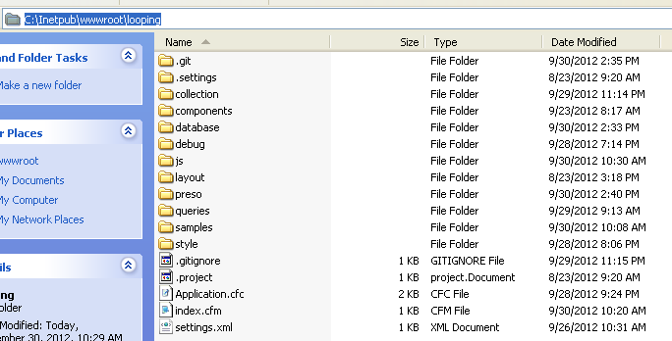

1. Create a Datasource
   1. **Microsoft Access with Unicode :  looping**

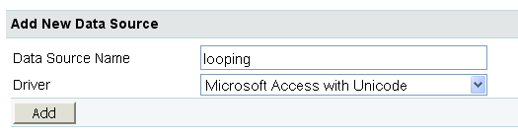

* 1. Data Source Name = looping
  2. <your web root>\looping\database\looping.mdb

Probably: C:\Inetpub\wwwroot\looping\database\looping.mdb

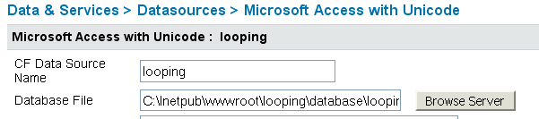

1. Browse to <http://localhost/looping/>

